Wellness Policy School Plans for the 2024-2025 School Year
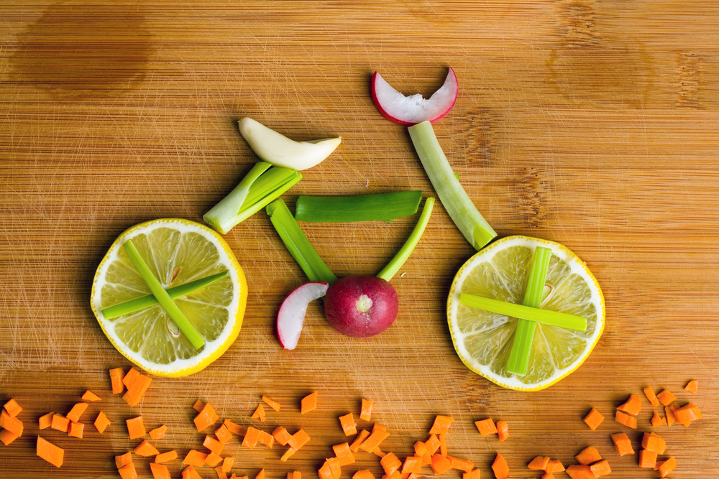
School Name: __Burns Science and Technology Charter School__
Principal’s Name or Person Responsible for Plan: ___Daniel Hargrave Phone: 386-210-4915
- Each school must have a wellness plan in place and a wellness contact person identified for each school (this person cannot be a School Way Café employee). Please provide name and ext. if different than above: NA, Same as above
- Ensure your school website contains a link to the Volusia County Schools Wellness Policy. If not, create the link for your website.
- If you are not already, we encourage your school to become a “Team Nutrition School” www.fns.usda.gov/tn/.
- The policy encourages nutrition education curriculum programs and to provide opportunities for physical activities. The policy also recommends using rewards and incentives that are not food related and limiting sweet treats for refreshments and parties.
Part I: Goals - List your wellness goals for the upcoming school year (additional goals can be added). File a copy under Wellness Policy 2024-2025 and e-mail a copy or send a hard copy to the School Way Café, attention Lindsey Bell ldbell@volusia.k12.fl.us and a copy to your Area Superintendent by September 15th, 2024
Part II: Evaluation - Evaluate the outcome of all goals at the end of the school year and e-mail a copy or send a hard copy by June 4th, 2024 to the School Way Café attention Lindsey Bell ldbell@volusia.k12.fl.us.
*Note: Documentation is required to validate the completion of your goals.
**Note: See the attached Wellness Tool Kit for ideas to use for your wellness plan.
Part I – Complete by Sept 15th, 2024 | Part II - Complete by June 4th, 2025
Goals for 2024-25 | Implementation Evaluation
- Nutrition Ed: We will continue with our goal and expand it. Students will learn the food process by planting seeds and transferring plants from the greenhouse to garden beds and geodesic hydroponic dome. They will garden and harvest, providing food for their class while learning the food value of vegetables for a healthy body.  Teachers use Harvest of the Month to guide teaching health, science, LA, and math. Informational Nutrition Posters hang throughout the cafeteria. Nutrition | Goal was successfully implemented.  Goal was partially implemented.  Comments:  X  Was not able to implement goal this school year.  Comments:  Documentation is available at school site and easily  X  accessible for audit.
Goals for 2024-25 | Implementation Evaluation
Quarterly Newsletters spotlight vegetable of the Month, healthy snacks, and recipes. Continuing the “table to garden” salad bar.

Additional projects for the 2024-25 school year will be:
- USDA 2 Bite Club will continue through Health and Wellness classes.
- Kindergarten is covering a unit on nutrition and will be encouraging students to try new healthy foods.
- PE department is covering a unit on nutrition, healthy choices, and choosing my plate.
- Biology Courses reviewing macromolecules such as proteins, fats, and carbohydrates and how they are important to the body.
- Grade Level Vegetable Gardens
- Physical Education/Activity:  Continue and expand the program. Students experience rigorous physical challenges while learning what activities keep body muscles fit. Individual student physical progress is tracked (data). This curriculum will continue in 2024-25 with the third through 12th grades.  Mindful movement is also practiced by students who learn the value of breathing and stretching for mental excellence.  Parents receive a Newsletter for better communication that incorporates information on Health & Wellness.  Additional Family physical activities include: Morning Mile and “Color Bash,” (teams of mixed ages accept field day challenges). Additional Activities: Running, Flag Football, Volleyball, Cheerleading, Basketball, Cross-Country, Soccer, Golf Club, Dance (eaglets), and Beach Volleyball, Campus Clean Up and Walkie Talkie (faculty and staff walking group). | Goal was successfully implemented.  X  Goal was partially implemented.  Comments: Everything was completed except for  The Health & Wellness Newsletter, and Heart and  Soul for 6-8 graders.  Was not able to implement goal this school year.  Comments:  Documentation is available at school site and easily  X  accessible for audit
- Other School-based Activities:  There will be Classroom Gardens  FFA and 4H – FFA for students in grades 6-12 who are in an Agriculture class. 4H Club for students in grades K-5.  Students are encouraged to stay hydrated with access to quality drinking water in all areas of the school. Filtered water fountains. The addition of more drinking fountains than the 2024-25 school year.  In 2024-25 teachers will be encouraged to use non-food for rewards instead of using food.  Plan for classroom sanitation.  Teach students about personal hygiene, such as washing hands and touching their faces | Goal was successfully implemented.  Goal was partially implemented.  X  Comments: All was implemented except for a partial  implementation for teachers to use non-food for  rewards instead of using food.  Ideas for the 2024-25 School Year:  - Morning walk before school. (Implemented)  - Consistent check of the School’s AED Defibrillators. (Implemented)  - Convert the wellness newsletters to a PDF and send it out through the school’s communication platform. (Implemented)  - CPR offered to all staff through VCFD through Matt Daly  Was not able to implement goal this school year.  Comments:  Documentation is available at school site and easily  X  accessible for audit.
Goals for 2024-25 | Implementation Evaluation
- Nutrition Promotion: Ms. Faulkner  Working toward less processed foods. The BST kitchen prepares fresh hot, nutritious meals for breakfast, lunch, and healthy after-school snacks.  - Market Breakfast to increase ADP (Average Daily Participation)  - Kids are able to get meals at any time.  Addition of a fresh salad bar, available to students, faculty, and staff.  The school will provide clear and consistent messages that promote and reinforce healthy eating and drinking of plenty of water.  This will be accomplished through a “Good Nutrition” campaign using bulletin boards (“Fruit and Vegetable of the Month”), posters, morning messages on the school news, and inclusion in Newsletters to Parents.  Support for the health of all students and staff is demonstrated by health screenings. | Goal was successfully implemented.  X  Goal was partially implemented.  Was not able to implement goal this school  year.  Comments:  Documentation is available at school site  X  and easily accessible for audit.
- Assurance:  We assure that the guidelines for reimbursable meals shall not be less restrictive than the regulations and guidance issued by USDA | Goal was successfully implemented.  X  Goal was partially implemented.  X  Comments:  Was not able to implement goal this school  X  year.  Comments:  Documentation is available at school site  X  and easily accessible for audit.
- Guidelines for competitive foods and fundraisers:  Competitive Foods  - All foods and beverages sold on school grounds to students outside of reimbursable school meals are considered “competitive foods.” Competitive foods include items sold a la carte in the cafeteria, from vending machines, school stores, and for in-school fundraisers.  - Unless being sold by the school food service program, it is impermissible for any competitive food item sold to students during the school day to consist of ready-to-eat combination foods of meat or meat alternate and grain products, as defined in 7 CFR 210.10 and 210.11. (FAC 5P-1.003)  - All competitive food items must comply with the nutrition standards for competitive food as defined and required in 7 CFR 210.11.  - To be allowable, all competitive food items sold to students must meet general nutrition requirements¹ and nutrient standards²  Fundraising  - Fundraising efforts will be supportive of healthy eating by complying with all applicable regulations and nutrition standards for competitive foods while also emphasizing the sale of non-food items.  - No fundraisers that include the sale of food items will occur until thirty (60) minutes after the conclusion of the last designated meal service period.  - NOTE: The school is allowed an exemption from the standards for competitive foods for the purpose of conducting infrequent school-sponsored fundraisers; for a K-8 school, the maximum number of days per year to conduct exempted fundraisers is 10 days.  - The wellness team will maintain a school calendar identifying the dates when exempted competitive food fundraisers will occur. (FAC 5P-1.003) | X  Goal was successfully implemented.  Comments: Communication was not  through a calendar, per say. Dates/Times  were communicated with families and  community members through social media,  email, and the school website.  Goal was partially implemented.  Was not able to implement goal this school  year.  Comments:  Documentation is available at school site  and easily accessible for audit.
- Wellness goals and policy updates will be provided to students, parents, staff, School Advisory, and School Board.  Information and updates are also available on the Burns Sci-Tech Website at www.burnsscitech.org, and notifications are sent out by the Principal on the school’s social media.  The wellness team shall prepare a report annually evaluating the implementation of the policy and include any recommended changes or revisions. | Goal was successfully implemented.  X  Goal was partially implemented.  Was not able to implement goal this  school year.  Comments:  X  Documentation is available at school site  and easily accessible for audit.
- The wellness team will collect data and meet three times per year to review the nutrition and physical activity policies and evaluate the student health program’s effectiveness and impact on students and teachers. School Food Service Staff will ensure compliance with nutrition policies within the school food area.  - At the final Burns Sci-Tech public school board meeting of the year, the Wellness Plan will be discussed, and all stakeholders will be asked to provide feedback on the policy. All comments and recommendations will be recorded, reviewed, and considered | Goal was successfully implemented.  Goal was partially implemented.  X  Comments: The Wellness Team only met  two tmes this past school year. The School  Food Service Staff ensured compliance with  the nutrition policies. The Wellness Plan is  scheduled to be presented at the June 24,  2025 School Board Meeting.  Was not able to implement goal this  school year.  Comments:  Documentation is available at school site  X  and easily accessible for audit.
- ¹General nutrition requirements:
- Be a grain product that contains 51 percent or more whole grains by weight or have as the first ingredient a whole grain; or
- Have as the first ingredient one of the non-grain major food groups: fruits, vegetables, dairy or protein foods (meat, beans, poultry, seafood, eggs, nuts, seeds, etc.); or
- Be a combination food that contains 1⁄4 cup of fruit and/or vegetable; or
- Contain 10 percent of the daily value of a nutrient of public health concern based on the most recent Dietary Guidelines for Americans (i.e., calcium, potassium, vitamin D or dietary fiber). Effective July 1, 2016, this criterion is obsolete.
Nutrition standards for beverages: Portion sizes listed are the maximum that can be offered.
Beverages | Elementary | Middle | High
Plain water | unlimited | unlimited | unlimited
Unflavored low-fat milk | 8 fl. oz. | 12 fl. oz. | 12 fl. oz.
Unflavored or flavored fat-free milk | 8 fl. oz. | 12 fl. oz. | 12 fl. oz.
100% fruit or vegetable juice | 8 fl. oz. | 12 fl. oz. | 12 fl. oz.
100% fruit or vegetable juice diluted with water but no added sweeteners | 8 fl. oz. | 12 fl. oz. | 12 fl. oz.
Calorie-free, flavored water and other flavored drinks | Not allowed | Not allowed | 20 fl. oz.
Low-calorie (5 calories or less per 8 fl. oz.) | Not allowed | Not allowed | 20 fl. oz.
Low-calorie (40 calories or less per 8 fl. oz.) | Not allowed | Not allowed | - fl. oz.
²Nutrient standards:
Nutrient standards | Snack Item | Entrée Item
Calories | 200 calories or less | 350 calories or less
Sodium Limits | 230 mg or less | 480 mg or less
Total Fat Limits | 35% or less of total calories | 35% or less of total calories
Saturated fat | 10% or less of total calories | 10% or less of total calories
Sugar Limits | 35% or less of weight from total sugars | 35% or less of weight from  total sugars
Exemptions:
- Entrées served in the NSLP/SBP on the day of service and the following school day.
- Fresh, frozen or canned fruits and vegetables with no added ingredients, except water, which are packed in 100 percent juice, extra light syrup or light syrup

10.

Goal was successfully implemented.
X

Goal was partially implemented.
Comments:

□ Was not able to implement goal this school year.
Comments:
X
Documentation is available at school site and easily accessible for audit.

- Principal – Daniel Hargrave shall ensure compliance with established school-wide nutrition and physical activity policies.
- www.burnsscitech.org

