Burns Sci-Tech Charter School
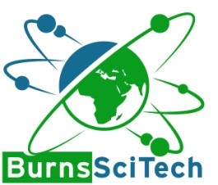

Workshop Agenda
March 25, 2025 – 4:00 pm HS Makerspace
- Call meeting to order.
- Pledge of Allegiance.
- Roll Call
- Reports and Discussions:
  - Board of Director Interviews with prospective board member applicants.
- Kylee Montgomery
- Sheneya Allen
- Darcia Bair
- John Drake
- Jamie Sulle
- ?
- Charlotte Gillis

- Adjournment.

